**Assignment 2 – Report**

**Description of algorithms.**

The first algorithm is based on backtracking and utilizes two techniques to optimize the search. The idea is to discover all ways to reach the goal and determine the way that has the optimal length. However, pure backtracking needs to be optimized to speed up the search for solutions. The first optimization technique allows not to consider the solutions whose length of the approximate path is greater than the length of the current minimal path. At each new step, the program checks if the sum of path length discovered and Chebyshev distance from the current cell to home is less than the number of cells in the currently minimal path. The second technique is used to first observe the cells from which the estimated distance to home is minimal. At each step, the candidate cells are prioritized, and there the most promising cell is treated first. This method gives improvements when applied together with the first one. Also, the prioritization allows to implementation of different perceptions of Covid. Apparently, for the second variant, there can be added overhead on cost for cells which Moore neighborhood contains infected cells to make the agent beware of the Covid.

The second algorithm is based on the A-star algorithm. Note that the set of all solutions for the path from the agent to the home could split up into two subsets. The first set contains solutions for paths from the agent to the home but does not pass through the mask or doctor. The second set consists of solutions that go through the mask or doctor. The cost of a move from one cell to any adjacent is set to be 0. The Manhattan distance allows estimating the cost of a move from the current cell to the home. Likewise, for the second variant, there can be added overhead on the estimated cost for cells which Moore neighborhood contains infected cells to make the agent beware of the Covid.

**Statistical analysis.**

Statistical analysis of Backtracking and A-star searching algorithms was performed based on the execution time of these algorithms (and their variants) on the randomly generated maps. Data set consists of 30 entries, each of them having 4 runtimes for different algorithms (see Figure 1).

The t-values were computed in Google Sheet. The sheet is [available online](https://docs.google.com/spreadsheets/d/1OIyuA3rqARgKR9eBLxDL9wh9p4IGWd_KUnD5hKO4hIQ/edit?usp=sharing).

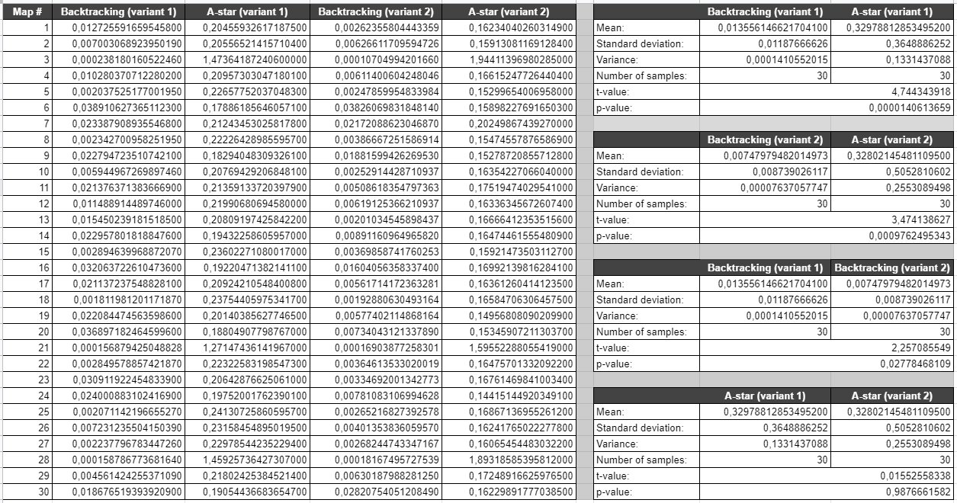Figure 1. Student’s t-test

Assume that all samples have normal distribution. Thus, for hypothesis testing there could be used Student’s t-test. Recall, the t-value could be found as

 (Eq. 1)

where ,  are sample means, ,  are sample variance of two samples , of sizes ,  accordingly.

For the following section take two-sided significance level  and degrees of freedom . Consequently, from the t-distribution table the critical level is 2.045.

1. Comparison of Backtracking (variant 1) and A-star (variant 1) algorithms.

The null hypothesis  reflects that there is no significance difference between samples for Backtracking (variant 1) and A-star (variant 1) algorithms, i.e., the algorithms are the same. As an alternative hypothesis  take the opposite to  point that there is significance difference between two samples and algorithms are different.

Using (Eq. 1) compute the t-value for the samples: . Obtained  is greater than the critical level. The Null hypothesis is rejected and we accept the alternative hypothesis.

Similarly, for the obtained there can be found. The is less than chosen significance level, and therefore the  is rejected.

Hence, the Backtracking (variant 1) and A-star (variant 1) algorithms **are different**.

2. Comparison of Backtracking (variant 2) and A-star (variant 2) algorithms.

The null hypothesis  reflects that there is no significance difference between samples for Backtracking (variant 2) and A-star (variant 2) algorithms, i.e., the algorithms are the same. As an alternative hypothesis  take the opposite to  point that there is significance difference between two samples and algorithms are different.

Using (Eq. 1) compute the t-value for the samples: . Obtained  is greater than the critical level. The Null hypothesis is rejected and we accept the alternative hypothesis.

Similarly, for the obtained there can be found. The is less than chosen significance level, and therefore the  is rejected.

Hence, the Backtracking (variant 2) and A-star (variant 2) algorithms **are different**.

3. Comparison of Backtracking (variant 1) and Backtracking (variant 2) algorithms.

The null hypothesis  reflects that there is no significance difference between samples for Backtracking (variant 1) and Backtracking (variant 2) algorithms, i.e., the algorithms are the same. As an alternative hypothesis  take the opposite to  point that there is significance difference between two samples and algorithms are different.

Using (Eq. 1) compute the t-value for the samples: . Obtained  is greater than the critical level. The Null hypothesis is rejected and we accept the alternative hypothesis.

Similarly, for the obtained there can be found. The is less than chosen significance level, and therefore the  is rejected.

Hence, Backtracking (variant 1) and Backtracking (variant 2) algorithms **are different**.

4. Comparison of A-star (variant 1) and A-star (variant 2) algorithms.

The null hypothesis  reflects that there is no significance difference between samples for A-star (variant 1) and A-star (variant 2)algorithms, i.e., the algorithms are the same. As an alternative hypothesis  take the opposite to  point that there is significance difference between two samples and algorithms are different.

Using (Eq. 1) compute the t-value for the samples: . Obtained  is less than the critical level. The Null hypothesis is failed to reject, so the is accepted.

Similarly, for the obtained there can be found. The is greater than chosen significance level, and therefore the  is failed to reject.

Hence, the A-star (variant 1) and A-star (variant 2) algorithms **are same**.

**Description in terms of PEAS.**

By the problem statement, the agent can be categorized using the Performance measure, Environment, Actuator, Sensor (PEAS) model. Primarily, the Performance measure might be expressed in terms of the run outcome: either win or lose. Also, the number of steps reflects the efficiency of the agent: the fewer moves in the found path, the better. Further, the time spent on finding the solution indicates how fast the system searches for the optimal path. At each step, various heuristics might be used to prioritize the candidates and evaluate the position. The Manhattan and Chebyshev distances could be applied to approximate the residual path and estimate how candidate move affects the distance to home. Besides, the agent could assess the surroundings of the candidate position. It either explores the neighborhood of infected cells first or beware of infected cells and does not go near them (variant 2).

The environment is a lattice of fixed size with one Actor, two Covid, one Home, one mask, and one doctor agent. The Moore neighborhood of cells with Covid agent is infected. Consequently, the agent can go through it only with the taken mask or after a visit to the doctor. The described environment is partially observable as the agent does not know the location of the mask and doctor. However, this knowledge is essential to guarantee the. Furthermore, the environment has multiple agents: Actor agent, Home agent, Mask agent, Covid agents. The agent cannot foresee will there be a mask or doctor in the next cell. Hence, the environment is stochastic. Any move during the search is dependent on the previous sequence of moves, and therefore, the environment is sequential. As the agent searches for the optimal move, the environment does not change, so the environment is static. Yet another property of this environment is discreteness. There can be defined the state as a current path and cell candidates. The environment evolves by going from one state to another. The designer of the agent in advance does know all rules in the environment. The agent can go to any adjacent cells in case it did get either mask or doctor, and to non-infected otherwise. It makes the environment known.

Let the Actor agent be a robot driven by wheels equipped with Covid perceiver and camera. As the actuators, the Actor agent has wheels. The agent can move from one cell to another. As sensors, the agent has the camera and Covid perceiver. The camera captures the settings of the cell and is used to determine whether there is either Mask, Doctor agents, or Home. Using a Covid perceiver allows the agent to feel the position of the covid within a radius of one cell (option 1) and a radius of two cells (option 2).

**Graphical representation of maps that were impossible to solve.**

In the source file *map.pl* there were prepared two maps that are impossible to solve. They are located in rules *impossible_map1_9x9* and *impossible_map2_9x9* (see Figures 2, 3).

The graphical representation of map *impossible_map1_9x9* is presented below. Apparently, there are two Covids that block the agent and do not allow to it move. Since both mask and doctor are unreachable from initial position, there is no solution for this map.

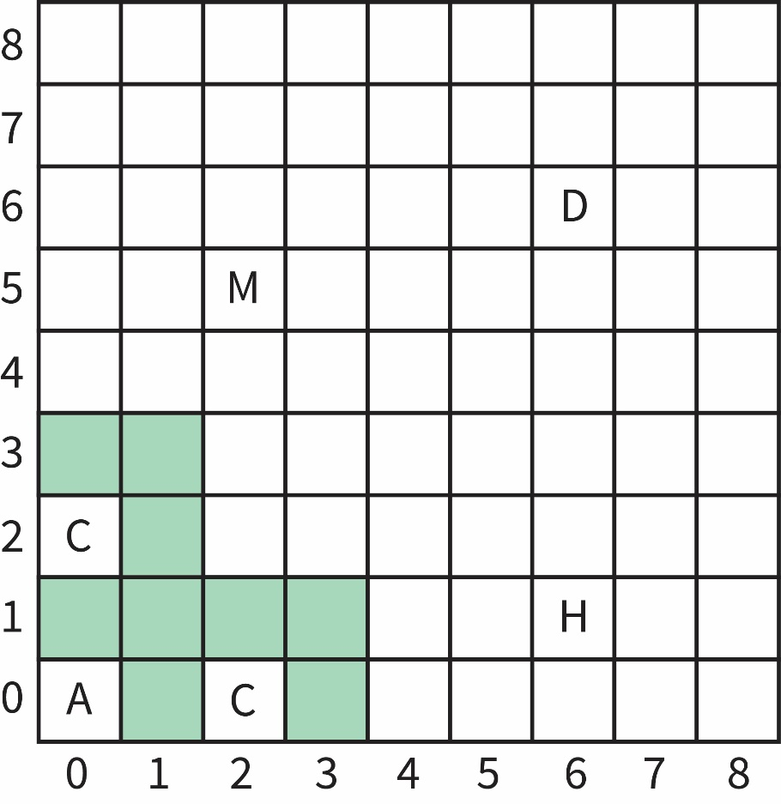

Figure 2. Visualized *impossible_map1_9x9*

The graphical representation of map *impossible_map2_9x9* is presented below. Similarly, there are two Covids that make the mask and doctor unreachable from initial position. Consequently, there is no way to overcome the barrier and solution for this map cannot be found.

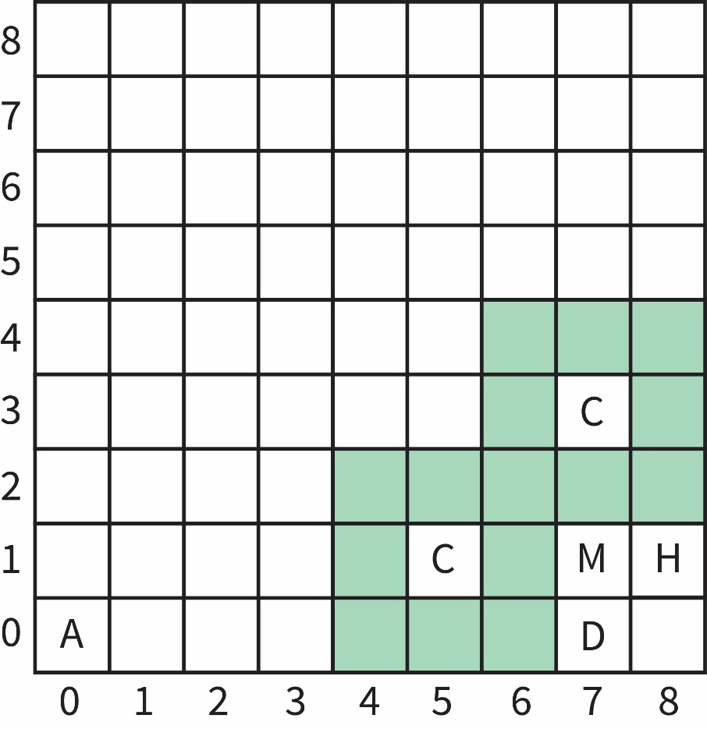

Figure 3. Visualized *impossible_map2_9x9*

**Reference list:**

1. J. Capablanca, N. de Firman, "Chess Fundamentals (Completely Revised and Updated for the 21st century)," pp. 24-25, 2006.
2. T. Guntz et al., "The Role of Emotion in Problem Solving: First Results from Observing Chess, " in *Modeling Cognitive Processes from Multimodal Data (MCPMD) at 20th ACM International Conf. on Multimodal Interaction (ICMI2018)*, Boulder, Colorado, USA, Oct. 2018. Accessed: Jan. 27, 2020. [Online]. Available: <https://arxiv.org/pdf/1810.11094.pdf>
3. S. Russel, P. Norvig, "Artificial Intelligence: Modern Approach," 3rd ed., Harlow, England, Pearson Education, p. 165, 2016.
4. S. Russel, P. Norvig, "Artificial Intelligence: Modern Approach," 3rd ed., Harlow, England, Pearson Education, p. 167, 2016.
5. F. Beal, "A generalised quiescence search algorithm," in *Artificial Intelligence*, vol. 43, ch. 1, pp. 85-98, Apr, 1990.
6. F. Hapgood, "Computer chess bad-human chess worse, " in *New Scientist Journal*, London, UK, pp. 827–830, Dec. 23, 1982. Accessed: Jan. 27, 2020. [Online]. Available:

<https://books.google.ru/books?id=_n1vr0_RbXoC&pg=PA827&redir_esc=y#v=onepage&q&f=false>